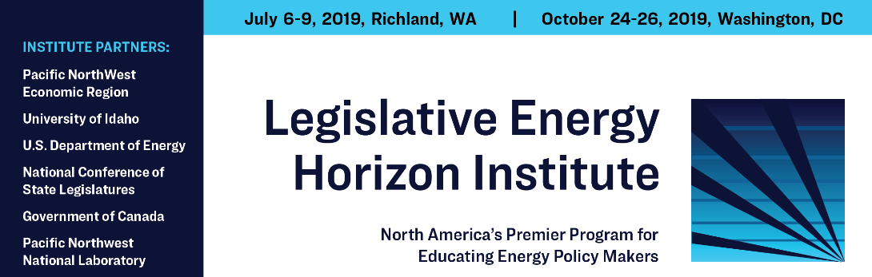

2024 Legislative Energy Horizon Institute Sponsorship Opportunities

The Legislative Energy Horizon Institute (LEHI) is the premier program for educating policymakers about the North American energy infrastructure system. This intensive 60-hour certificate program is designed to provide state and provincial legislators and policymakers intensive exposure as to how North American energy infrastructure delivers energy to consumers, how energy infrastructure is built and financed, and regulations and market impacts. A disconnect can often exist between those that set our energy policy and an understanding of how our infrastructure operates. High turnover in state legislative bodies can exacerbate this issue. LEHI was created in 2009 to address this challenge and provide a robust energy education program that provides legislators and policymakers with a well-rounded view of our energy infrastructure and delivery network, from traditional energy sources and renewable innovations to the future of our shared energy system. With an annual cohort of 40 participants, LEHI provides legislators and policymakers across North America with the knowledge of how energy is delivered to consumers and to assist them in making educated policy decisions.

Over the past decade, over 400 legislators have graduated from LEHI, and participants continue to rate it as one of the best legislative policy education programs for policymakers to attend. With major support from the U.S. Department of Energy and Government of Canada, and world-class faculty from academia, industry, and government, the Institute seeks to bring together diverse viewpoints and ensure a well-rounded learning experience. Graduates of the program are awarded a certificate in energy policy planning from the University of Idaho.

For more information on LEHI and the dates for this year’s Institute, please visit www.lehi.institute.

2024 Sponsorship Levels

Sponsorship of this innovative program is available at three levels:

Legacy Sponsors A multi-year commitment for two years of $40,000 total or $20,000 per year.
- Legacy Sponsors are launch sponsors of the original pilot program or sponsors that make more than a two-year financial commitment.
- Legacy Sponsors receive listing by seniority on all materials and at events.
- Get one trustee position to guide planning efforts, set the curriculum for the course, and coordinate alumni activities.
- Allows up to two personnel to shadow each class during our class sessions.
- Option to host social function, i.e. dinner, for participants at class session.
- Unlimited invitations to graduation reception for participants. Graduation reception usually held at Canadian Embassy in D.C.
- Logo Identity on all LEHI material and products.
- Help identify potential LEHI participants working with PNWER, NCSL, National Governors’ Association and the Energy Council established nomination procedures.

Annual Sponsor A two-year commitment of $24,000 or $12,000 per year.
- Logo Identity on all LEHI products
- Allows one person to shadow on-site seminars
- Introduction and recognition at class location

Classroom Sponsor A one-time commitment for one of the two classroom sessions of $5,000
- Logo Identity on all on-site material
- Introduction and recognition at class location

Program Partners

The Pacific Northwest Economic Region (PNWER) is a statutory, non-profit, public/private partnership chartered by the Northwest states of Alaska, Idaho, Montana, Oregon and Washington and the Western Canadian provinces of British Columbia, Alberta, and the Yukon and Northwest Territories. PNWER facilitates legislative working groups including energy on a variety of topics and launched the LEHI program in 2009. PNWER provides fiscal and logistics management of the LEHI Program.
The National Conference of State Legislatures (NCSL) represents the legislatures in the states, territories, and commonwealths of the U.S. Its mission is to advance the effectiveness, independence, and integrity of legislatures and to foster interstate cooperation and facilitate theexchange of information among legislatures. NCSL has been the major national partner with PNWER producing LEHI, and assisting in the recruitment of each year’s cohort.
The University of Idaho Energy Executive Course (EEC) engages the energy industry's best leaders from diverse business backgrounds in a dynamic interchange of knowledge, insight, and expertise. EEC has earned a worldwide reputation as the premier industry-driven executive education program designed specifically for energy leaders. The University of Idaho is the Academic partner helping facilitate the faculty for the Institute.

The National Governors Association (NGA) Energy Program provides Governor’s energy advisors with access to the Energy Policy Learning Network to provide Governors with unbiased, state-based energy solutions that foster a reliable, resilient, affordable, and clean energy system. NGA assists in the development of the curriculum and recruitment of state Governor’s Energy Advisors in each cohort.

Women in Government convenes state legislators and stakeholder experts with broad perspectives and experiences to amplify the work of female lawmakers.

The Energy Council is a non-partisan legislative organization founded in 1975. The organization was formed to provide a forum for state legislators interested in energy policy. It allows legislative policymakers to maintain a dialogue and learn more about energy issues of importance to their states, citizens, environment and revenue base. For energy producing states and provinces, a better understanding of energy markets, technology and policy, as well as related environmental concerns, benefits lawmakers and their constituents. The Energy Council is a proven resource for developing energy policy leadership.

Contact:
Matt Morrison
CEO
Pacific NorthWest Economic Region
matt.morrison@pnwer.org
Nate Weigel
Program Manager
Pacific NorthWest Economic Region
nate.weigel@pnwer.org

Philene Taormina
Associate Director, Environment, Energy & Transportation
National Conference of State Legislatures
philene.taormina@ncsl.org

Austin Igleheart
Energy Policy Specialist
National Conference of State Legislatures
austin.igleheart@ncsl.org

Dan Lauf
Energy Program Director
National Governors Association
dlauf@nga.org

Meredith Martino
Executive Director
Women in Government
mmartino@womeningovernment.org

